Technical documentation

VR STEAM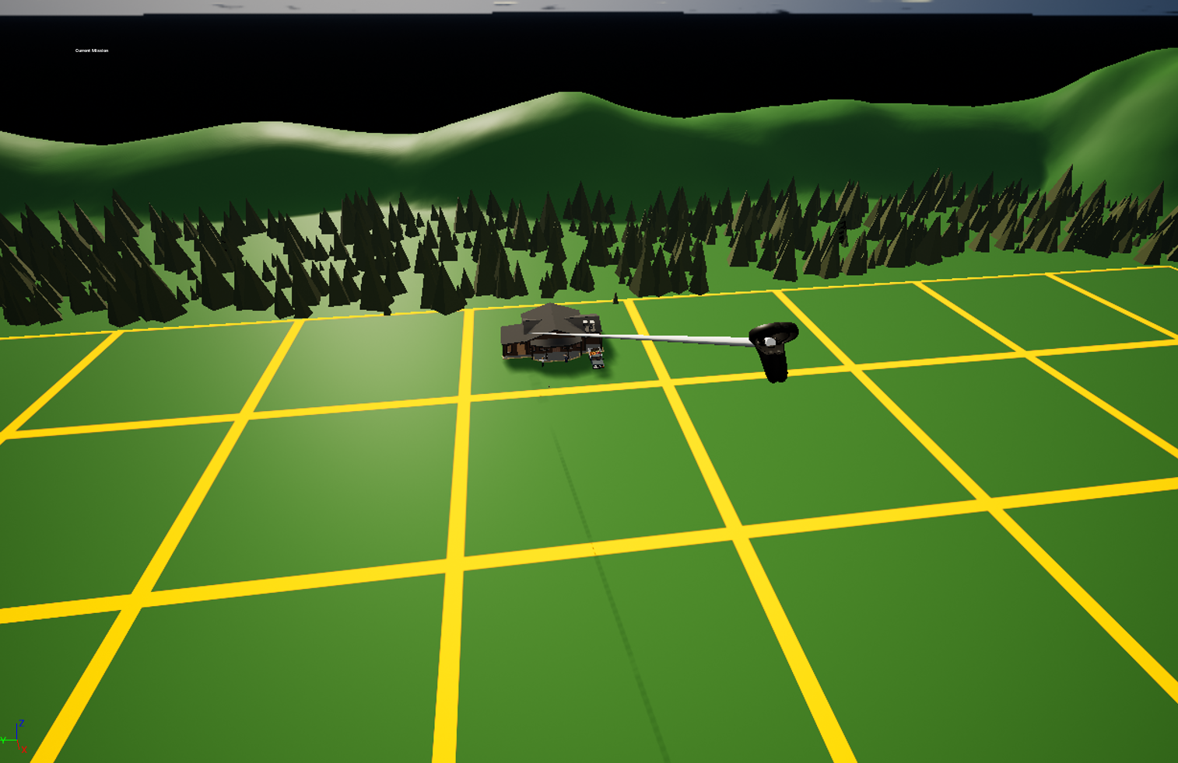

[2022-12-16]

Mohmad Mahra, Chet Jin Edwin Mak, Nirari Daoud, and Alexander Marklund

**Table of content**

**Classify the system** **2**

**Review of milestone 1** **3**

Feedback and Solution/improvement from client: 3

1. Defining tasks (Gameplay) ? 3

2. World building? 3

Feedback and Solution/improvement from our peers: 4

Peer feedback 1# 4

Peer feedback 2# 6

Peer feedback 3# 7

**Development testing procedure** **8**

**Packaging/deployment/procedure of the system** **9**

# Classify the system

The vision of the project is to connect an art perspective into a STEM thinking environment.

Our approach to this is to make a game about stem in which art is encouraged.

Because of that we choose to make the interface as art friendly as possible.

As a result, the interface of our project was chosen to be a virtual reality user interface system to support the feeling of presence. That will encourage the players to be engrossed by the experience making them feel as if they are in that reality. Another important reason we did that is also because it included tools and properties that fit very well with the game in a way that will minimize the hindrance for art to prosper. Few of which is making it both easy and flexible to view the surrounding while at the same time control your surrounding both whilst keeping interactions feeling natural and unimpeded by the complexity.

The project is using specifically Oculus Quest VR to make the experience light and comfortable with the accurate tracking that is needed to play for hours.

# Review of milestone 1

## Feedback and Solution/improvement from client:

### Defining tasks (Gameplay) ?

**Concept:** When discussing the game progression we had an idea of how to unlock new islands/cities through some sort of task. These tasks are to have some sort of relevance to the concept STEAM thought solving it in an artistic way. Example solving simple math problems through building blocks.

**Feedback:** Our client liked the idea however he wanted to add some sort of interaction with the citizen. As an example, a problem a citizen needs help with. He also added that it would be great if the solving part had an effect in the city too.

**Solution:** We ended up with letting the players accept the task from the npc that we created and slightly changing the task we had for the demo.

### World building?

**Concept:** The idea we came up with was to include multiple islands that would represent different parts of the STEM. Every island would have their own unique looks and problems that are tied with a subject such as math island and so on. The goal was to help each city to acquire rocket parts to build a spaceship so that the player flies to space where they will be unlocking free mode. Free mode is essentially just an empty plane where the player can build/decorate however they want with the items they have acquired from Planet STEM (not official name).

**Feedback:** The feedback was that the idea is great when it comes to having multiple islands and that each island had unique looks and problems. However the name of the islands wasn't as appealing, and the idea of acquiring parts for a rocketship wouldn't be the most appealing goal for the current target users. But the idea of a free mode could be interesting.

**Solution:** In the end we ended up changing the name of the island to keep the concept of the unique looks and free mode. However we postponed how the player would acquire free mode and shifted the focus more towards fixing 1 island for the demo.

Few words:

Other than these main topics that were mentioned above, the client seemed pleased with the progress so far. He wanted us to continue giving us creative freedom and keep him updated on the progress and let him know if more feedback is needed.

## Feedback and Solution/improvement from our peers:

### Peer feedback 1#

**Scrum:**

The group's scrum plan looks neat and clean.

The work capacity for each member is displayed clearly which is good, so every member knows what is to be expected of every group member.

Good that a backlog is present, so the foundation of the project is always clear.

The sprint logs could have been a bit more descriptive. If I was a new member that was going to join this sprint group, I would not really know what the other team members are currently working on or have been previously. Because I wouldn't know what "Research" entails and it seems to have been a big part of both current and previous sprints. This is at least from the look of it, as it doesn't look like the Research handles has any more description/cards or checklists attached to them to know exactly what is being researched.

**Answer:** I might look confusing but everything is written either inside of each slide and as an example of the research, it's just a name for gathering information/ideas for the project. The thing we should have done is to put our names on each slide to show who is working on what. We just simply forgot to put our names on the task because everyone knew what to work on from our multiple small meetings. Putting our names would make inviting people to the project a bit easier.

UML:

I think the UML looks fine and displays the flow of logic quite well.

The only thing I could think of is maybe a bit more about the logic of the inner workings of the game itself, instead of simply Show Gameplay Scene. However, I can imagine that part might not have been implemented or pushed to a state where the group felt they had it all thought out yet.

**Answer:** Yes most of our ideas weren't fully implemented at that time but our ideas were there so we included photos to later come back too.

Github:

Not much to say here other than that it looks good.

I do however like that there is a description about the project in the repository! Makes it easy to understand the project at a first glance.

Requirement Document:

Great description about why this project was started and what the goals with it are!

A bit confusing what "islands" means as there is no explanation of what happened before the topic. Are there sections in the game? Actual islands that the player will be placed on?

Something that maybe I misinterpreted: "We are mainly interested in developing more users which are associated with the STEM

principles into the STEAM process." Is developing the right choice of words? I don't really understand what is being conveyed, might just be me.

**Answer:** The islands are supposed to be an expansion from the main city with its own unique environment and subject. But for this demo we mainly focused on the main city.

STEM stands for Science Technology Engineering Mathematics and STEAM stands for the same thing but the A stands for Art. The point we are trying to convey is to introduce STEM for women in an artistic way. Example not describe math as numbers but instead more of an interactable way for players to be more creative.

Power Point:

Great job overall on the powerpoint!

The only thing I was wondering about was assets. Mentions low poly assets. Are they made by your group? Downloaded? Were they already handed to you from your project manager/client etc.?

**Answer:** Nothing was made from our group, everything comes from EpicGames own market. Our client did not give us any assets but instead encouraged us to find assets so that we can focus more on the actual game.

Final conclusion:

Overall, I think the milestone was well documented.The major thing I would like for this group to think about in the future is to make the Scrum plan clearer. See my comments on the Scrum topic for details.

### Peer feedback 2#

Overall it looks good. It’s clear that you’ve put thought into your planning.

In the requirements document I would have liked to see a more structured list of functional and non-functional requirements for your project rather than only outlining it. The game ideation part of the requirement document could also use some expansion as references to multiple islands are made before even clarifying that the game would take place on one.

Trello looks very professional and so does the presentation. The UML is fine but feels a bit bare-bones as it doesn’t really take into consideration what the different classes etc would look like functionally. Instead only focusing on the application flow, which isn’t bad per se. All in all, it looks good.

In your requirements document there are two 1.3s. There seems to be no specific requirements of the project, just a discussion around the project itself. I'd say that adding specific requirements would benefit both the reader (me, in this case) but even more clearly yourself as developers. Another thing worth mentioning is that the project scope seems humongous. I'd try to scale down a bit. It's great to set goals and I'm all for ambitious goals, but you have to realize what you can do in such a limited time!

**Answer:** We have updated the documents and UML we have taken it in consideration of your feedback. For the island read Peer feedback 1# for the answer. The project scope is big so that everyone could get an idea of what the game will look like as the first draft. But in the end it was never our goal to complete everything but rather create a demo and implement as many features as we could to show others to see if it's worth continuing or if it needs to be changed.

The powerpoint looks solid! The UML seems to be a flowchart but that's also useful. If possible, you could provide a class diagram if applicable, that would clear up some confusion and make things crystal clear, at least in my view.

All in all, it looks solid! I just think you should consider cutting off parts of the project. Love the idea though, the final product would be cool! :D

### 

### Peer feedback 3#

I think you have a nice concept, with different islands and problems to solve, but I think it will take a lot of time to implement. The different perspectives you can take are interesting and sound fun for the player. Overall, I think the presentation was good though I wish to see more gameplay.

**Answer:** Yes indeed it will take a long time but it is something that pitch our client so that can later be shown to others for as much feedback as possible. The game has been updated to have a task but it is still in a very early stage in development.

# 

# Development testing procedure

The developers test the game each time we merge our github branches together to make sure everything works together as expected.

We do regular testing ourselves while developing the assigned features. This was made so we could test our solutions before calling us done for the day and merge. As we only had two Oculus Quests this procedure was a bit hard and we tried to use a booking system for the Oculuses to keep track of when people used them. This worked in some sense but as not everyone used this system regularly it got a bit abandoned along the way of development. This process of testing is not sustainable in a big project but can be done. As this was a small team with a small project we could succeed with this procedure!

In case of an detected error, the code does not have any error handling yet which means that we debug it in the traditional way of incrementally isolating the problem to one place and fix it.

This is only acceptable for small projects as well which we anticipated as mentioned before.

# 

# Packaging/deployment/procedure of the system

The gamification of the project is developed in Unreal Engine 5.0.3 and was later then built as an app to Oculus Quest VR using Unreal Engines built in project builder.

After that, the app can be released from the builded files into a software in the VR called “Meta Quest Store” which is like “appstore” or “playstore” as people might be familiar with but only for Oculus VR. This way everyone with an Oculus VR headset can download and install the game from “Meta” in their own headset.